**

M.G. den Hollander

Student number: 3803554

Fontys Hogescholen

ICT & Software Engineering

Version: 1.

**Research document**

#### Version

|  |  |  |  |  |
| --- | --- | --- | --- | --- |
| **Version** | **Date** | **Author** | **Changes** | **State** |
| 1 | 17-02-2023 | M.G. den Hollander | Created the document and added styling. | Concept |
| 1.1 | 20-02-2023 | M.G. den Hollander | Started working on the first sub-question for sprint 1. | Concept |
| 1.2 | 08-03-2023 | M.G. den Hollander | Started working on the second sub-question for sprint 2. | Concept |

**Distribution**

|  |  |  |
| --- | --- | --- |
| **Version** | **Date** | **To** |
| 1. |  |  |
|  |  |  |

# Table of contents

Table of contents 3

1 Introduction 4

2 Main question & Sub-questions 5

2.1 Main question 5

2.2 Sub-questions 5

3 Research methods 6

4 Results 9

5 Conclusions 13

6 Bibliography 14

# Introduction

During this graduation internship, there was an opportunity to work on an important assignment for Sligro, for which thorough research had to be conducted to ensure the best possible outcome. This document will provide all of the research subjects, and outcomes.

Firstly, the document will outline the specific details of the assignment and its objectives. It will also detail the current level of knowledge that is already possessed on each of the subjects relevant to the assignment at the outset of the research.

Then there will be described what research methods were used, which include a combination of the Field, Library, and Workshop strategies. The Field strategy involved conducting interviews with key stakeholders and experts within the company to gather first-hand information on their processes and systems. The Library strategy involved reviewing relevant literature and documentation, while the Workshop strategy allowed for hands-on experimentation and prototyping.

Then the results of the conducted research will be presented, detailing the advantages and disadvantages of the company's current automation techniques, as well as outlining the most efficient and sustainable ways to use automation within the company. This information will inform the conclusions drawn in the document, which will be based on a comprehensive analysis of the data collected through the research.

Throughout the research process, various sources have been consulted to ensure that the findings were accurate and comprehensive. These sources included academic articles, industry reports, company documentation, and expert interviews.

Overall, this document serves as a comprehensive account of the research conducted during the internship with Sligro. The findings and conclusions presented in this document are intended to provide a meaningful contribution to the relevant field of study, and it is hoped that they will be of value to those seeking a deeper understanding of the topic.

# Main question & Sub-questions

To provide structure to the research, One main question has been formulated with corresponding sub-questions. The main question can eventually be answered by investigating and answering these sub-questions. The main and sub-questions are presented below.

## Main question

For this research paper, the main question is:

* How does the implementation of a new robotic process automation technique ensure that automation is available as efficiently as possible?

## Sub-questions

To answer this main question, a number of sub-questions were formulated and elaborated on for the company:

1. Which techniques are used by the company regarding automation?
2. What are the advantages and disadvantages of these used techniques?
3. What are the key processes and activities that need to be decomposed and analyzed prior to implementing a new RPA technique?
4. What steps can be taken to increase the effectiveness of RPA in optimizing the current process and improving efficiency?
5. What is the most efficient and sustainable way to use automation within the company?

# Research methods

In this chapter, all of the used methods will be specified for each research question. The methods are sourced from the DOT research framework (Figure 1). The DOT research framework helps with giving structure to applied research regarding ICT projects[1]. In addition, it helps to determine the most effective methods beforehand and avoid unnecessary research in the future. Table

Figure 1 DOT research framework

1. Which techniques are used by the company regarding automation?

The question of which techniques a company uses for automation is an important one that requires a detailed analysis of their current practices. To answer this question, two main strategies will be used: **Field** and **Library**.

The most effective approach would be to use the interview method to better understand the specific techniques used by the company. By arranging an interview with the Product Owner (PO), it would be possible to gain insight into the company's current practices and map out the various techniques being used. This information would then be used to inform further research and analysis.

In addition to the interview method, the document analysis method will be used to gather more information on the company's existing practices. The PO has indicated that the company possesses its own documentation on automation, and is willing to share this. By examining this documentation, it would be possible to gain a more comprehensive understanding of the techniques being used by the company.

Last but not least, a task analysis could come in handy to better understand the flow of automation that needs to be improved. This will help collect information about the tasks the RPA solution will need to perform.

By using the interview, document & task analysis methods, it would be possible to gain a thorough understanding of the techniques currently being used by the company for automation.

1. What are the advantages and disadvantages of these used techniques?

Analyzing the advantages and disadvantages of the company's automation techniques is a crucial step in understanding the current state of automation and identifying potential areas for improvement. To answer this question, several strategies will be used, including **Field** and **Library** methods.

This sub-question can partially be answered by the interview of the previous sub-question. That interview can provide valuable insights into any problems or issues that the PO may have encountered with the current automation techniques.

Additionally, the best good and bad practices method can be used to evaluate the effectiveness of the company's current automation techniques. This method involves analyzing the company's existing practices and comparing them to industry best practices. By doing so, it is possible to identify areas where the company is excelling or struggling with its automation techniques.

Furthermore, the problem analysis method can be used to investigate why the company believes that its automation techniques are not currently optimal. By examining the underlying issues and challenges, it may be possible to identify specific solutions and strategies for improvement.

By combining these methods with the information gathered from the previous sub-question, it is possible to provide a comprehensive analysis of the advantages and disadvantages of the company's current automation techniques. This analysis can inform potential strategies for improvement and help the company to optimize its automation techniques to better meet its needs.

1. What are the key processes and activities that need to be decomposed and analyzed prior to implementing a new RPA technique?

It is important to map out all the processes and activities that the RPA solution must perform. To achieve this, two main strategies are used: **Library** and **Workshop**.

Specifically, document analysis is used to examine the documentation provided by the company to identify all the processes. Additionally, Decomposition is used to break down the complex system into smaller parts, ensuring its maintainability and robustness.

Lastly, it is important to conduct Requirements Prioritization to prioritize which requirements need to be implemented first, ensuring smooth execution of the final research question.

1. What steps can be taken to increase the effectiveness of RPA in optimizing the current process and improving efficiency?

The question of how automation can improve efficiency within the company is a complex one that requires a thorough analysis of the current state of automation and potential steps/strategies for improvement. This question can be approached with the answers to the previous sub-question, because of the disadvantages of the current way of automation. These disadvantages can be examined, and help identify areas where optimization is needed and the current process can be improved which helps as a preparation for the final research question. The strategies used for this question are **Field** and **Lab**.

In this case, one approach would be to conduct another interview with the PO to gain a better understanding of the company's specific requirements for improving automation. This would allow for a more targeted approach to optimization that addresses the specific needs of the company.

Additionally, document analysis could be used to gather more information on how automation is currently being utilized and where there may be room for improvement. By examining this, it may be possible to identify areas where automation could be optimized to improve efficiency and productivity.

Finally, it is important to conduct a system test on the current system so that any errors in the process can be identified, and a clearer picture can be formed of how improvements can be made with a new technology. The test can identify any issues or bugs that the current technique has, which could provide valuable insights into the areas that require improvement.

1. What is the most efficient and sustainable way to use automation within the company?

This last sub-question will determine the most efficient and sustainable way to use automation within the company, and combine the knowledge from all previous questions into an implementation of RPA in the process. Next to that, two main strategies will be used: **Library** and **Workshop**.

One way to approach this question is to use the business case exploration method, which involves analyzing the costs and revenues associated with various automation options to identify the most viable solutions for the company. This approach can help to identify the most cost-effective and efficient method(s) of implementing automation.

Another effective method is prototyping, which involves creating a minimum viable product (MVP) to demonstrate the best way of automation applicable to the company's operations. This approach allows for hands-on experimentation and testing to identify the most effective automation solutions.

In addition, it may be beneficial to hold an expert interview with the company's RPA specialist to gain valuable insights and support for this sub-question. This can help to ensure that the proposed solutions are aligned with the company's current automation capabilities.

# Results

In this chapter, the results obtained for each sub-question will be documented. All of the results will be divided into the research methods that have been used. The sources used for the research will be referenced via the footnotes, and will be listed at the end of this document as well.

1. Which techniques are used by the company regarding automation?

Interview

At the beginning of the graduation internship, an interview with the PO at Sligro made it clear which techniques are currently being used to apply automation. During the interview, the PO shared insights into the techniques used at Sligro to automate their processes. This information provides a foundation for understanding how automation is implemented in the organization. To explain the used techniques, it is important to understand the basics of the system.

Sligro currently operates on a system called AS400. AS400[2] is a computer system developed in the late 1980s for companies to run applications and perform data processing. Despite its age, this system is still widely used by companies because it is considered secure, robust, and reliable. Figure 2 shows the graphical user interface of this system. For the scope of the project, it has been agreed that this research specifically focuses on the financial department at Sligro.

Figure 2 GUI AS400

Sligro uses specific tools to automate tasks that would otherwise require an employee to do them every time. Some examples of these tasks include checking for financial mutations, handling errors caused by missing files needed for reports, or converting data from spooled files to PDF files that need to be stored on the appropriate department's drives. They have these tasks performed by a so-called "robot". This robot is simply a type of software recorder that executes the steps one by one on the AS400 itself. While the definition is called a robot, it is important to note that there is no AI/machine learning behind it.

As previously mentioned, the company uses so-called spool files. This comes from the technique of "spooling"[3], in which data can be temporarily stored for later processing. A spool file is a type of temporary data storage that contains data that is queued for processing on a computer system. This can be compared to the operation of a cassette tape. Figure 3 shows what a spool file might typically look like. In principle, anything can be stored in a spool file, but the spool files used during this internship mainly consist of financial data. Due to the sensitivity of the data, no example of such a financial spool file will be given.

Figure 3 Example spooled file

To dive deeper into the automation tool, the current documentation provided by the company was examined. From this, it was revealed that the tool is provided by a software vendor called Kofax. Kofax[4] is a company that specializes in Robotic Process Automation (RPA) and offers tooling such as recording software. Officially called information-capture software, it serves as a type of screen recorder in the case of Sligro, enabling actions to be automated. Kofax has a design studio, as seen in figure 4, which makes it very easy to automate processes based on a graphical user interface. On this platform, all robots can be viewed, and all the steps that the robots make are recorded.

Figure 4 Kofax Design Studio

In addition to Kofax's design studio, the robots also need to run at specific times. For this purpose, there is a special scheduler tool called the Kapow Management Console. As shown on figure 5, the robot that is studied during this internship is set to run every Monday between 7 and 8 in the morning, and every Tuesday to Sunday between 7 and 7:30. In this console, the robot can also be manually started if it does not start on its own.

Figure 5 Kapow Management Console

Task analysis

To gain a better understanding of all the tasks performed by the robot, a task analysis was conducted to examine all the steps the bot executes on the AS400. The steps could be derived from the design studio. As said earlier, the robot runs every Monday between 07:00 and 08:00, and every Tuesday to Sunday between 07:00 and 7:30. It runs for exactly fifteen minutes. Originally, it ran for 10 minutes, but because the tasks became larger, it had to be extended to 15 minutes, otherwise, the bot would stop before all the tasks were completed.

The tasks performed by the bot are as follows:

* Logging in on the AS400.
* Checking for any unprocessed financial mutations. The robot accomplishes this by verifying whether certain records are empty or non-existent. This can be seen in figure 6. If no records are present, the robot can proceed to the next task.Afbeelding met tekst

  Automatisch gegenereerde beschrijving

Figure 6 Empty Records

* If there are any unprocessed financial transactions, the robot will send an error message via email to the responsible parties (see figure 7). The robot will then continue to check every 15 minutes between 7:00 and 8:00 a.m. to see if the records have been processed. If the outstanding records are not processed by 8:00 a.m., the robot will need to be manually restarted or the tasks will have to be done manually.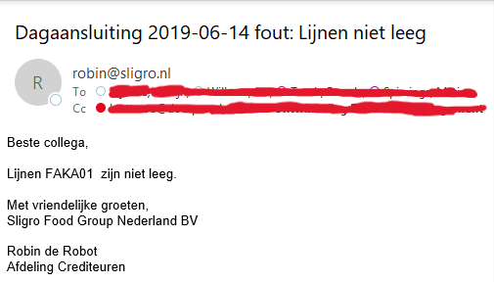

Figure 7 Error handling

* Once all financial mutations are processed, the robot moves on to printing necessary documents. It's important to note that these documents are not actually printed by a physical printer, but are converted from spool files to physical files on the server. Some examples of printed documents include outstanding purchase orders and purchase invoices. Once this data is converted, the robot can move on to the next step. An example of this step can be found on figure 8, where such a document is printed.

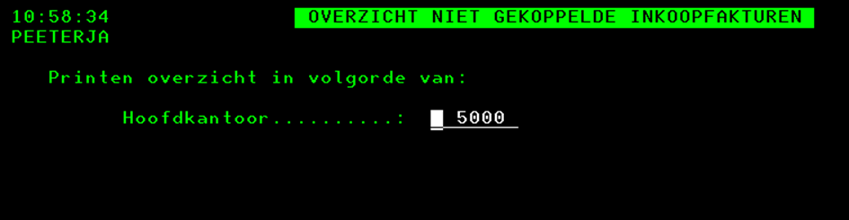

Figure 8 Printing documents

* In this step, the robot retrieves data from the previous step and places it in an Excel document. By setting up rules, the robot knows exactly which line in which file to search for the correct data. Figure 9 shows that the numbers in the Excel document are obtained from various overviews, with the highlighted blue lines being the list overviews from which the robot precisely retrieves the data, and the light orange ones being the calling procedures. 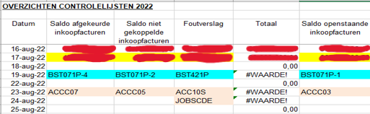

Figure 9 Moving data from physical file to Excel

* In the final step, the robot digitizes several lists from a spool file to a PDF file and then is sent to the hard disk of the appropriate department. Specifically, this concerns the lists "Outstanding purchase invoices" and "Overview of outstanding purchase orders". Figure 10 shows the result of this action. Afbeelding met tafel

  Automatisch gegenereerde beschrijving

Figure 10 Digitized files sent to the right department

Activity diagram

In order to provide a clear overview of all the tasks mentioned above, an activity diagram has been created using the principles of Lucidchart[5]. This diagram, which can be found on figure 11, visually represents the flow of the robot's activities from start to finish. By using this diagram, it becomes easier to understand the different steps involved in the process and how they are connected to each other. The diagram serves as a helpful tool for those involved in the development and maintenance of the robot, allowing for a better understanding of the entire process and facilitating any necessary adjustments or improvements.

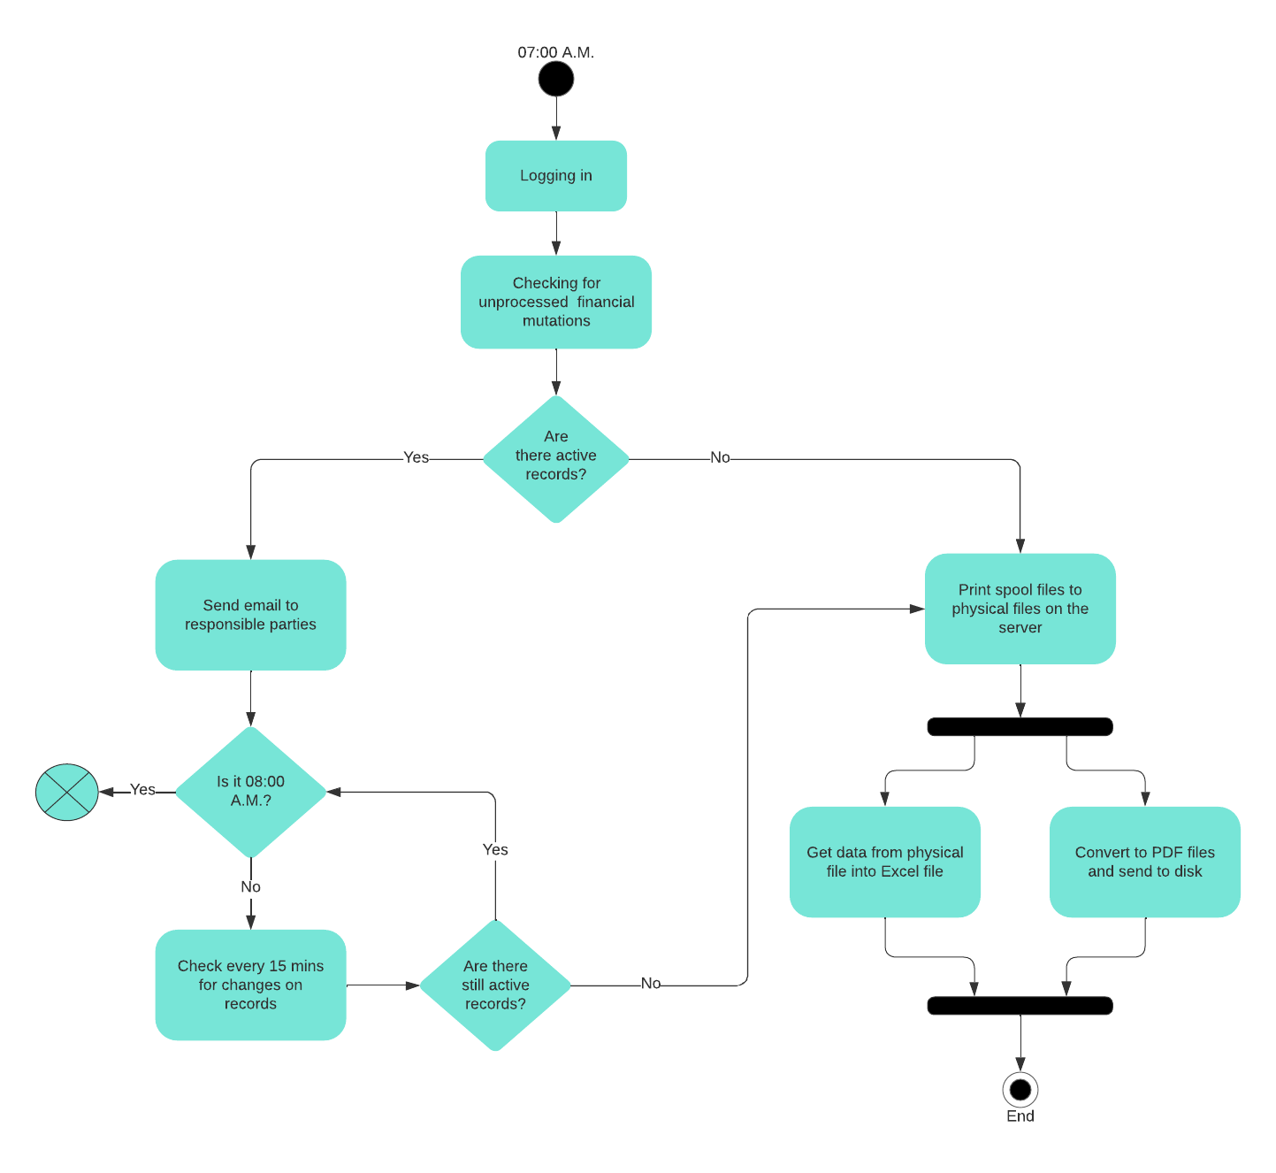

Figure 11 Activity diagram of the robot

1. What are the advantages and disadvantages of these used techniques?

Interview

This sub-question was partly answered by the interview conducted in the first sub-question. That interview revealed that the robot does not always work properly. Sometimes, the robot needs to be manually started instead of working automatically every day. It is still unknown why the robot does not start on its own, and it requires extra unnecessary work from the staff to manually start the robot. Additionally, looking at the activity diagram from the first sub-question on figure 9, it can be seen that when there are still active unprocessed financial transactions, the robot should send an email to the appropriate people so that these transactions can be processed. If this is still not done after 8 am, then the robot stops completely with its process, and the robot will need to be manually started again later, or the daily processing needs to be made manually. This is more related to the process than to the disadvantages of the technology used, but is still essential to remember for the prototype that will be developed for Sligro.

Kofax RPA provides several advantages to businesses that need to automate their processes. One of these benefits is its user-friendly design studio, which allows for easy mapping of all the necessary steps the robot needs to perform on the AS400 via a user interface. This studio functions as a software recording tool that saves the company time by eliminating the need to write scripts.

The user-friendly interface of the Kofax RPA design studio enables Sligro to create robots easily, without requiring extensive technical knowledge or expertise. The recording tool automates the process, eliminating the need for manual intervention, which results in a more efficient process.

Additionally, Kofax RPA enables Sligro to save a considerable amount of time and money. By automating several steps in the process, the solution eliminates the need for manual data entry, which can be tedious and prone to errors. The automation saves time, as the robots can perform the tasks in a fraction of the time it would take humans to complete them. The solution also reduces costs by minimizing the need for human intervention, which again reduces the risk of errors and the need for additional resources. This solution saves about 4 full-time employees' work, which would otherwise have to perform these tasks manually according to the PO.

Overall, the Kofax RPA solution is an effective tool to automate their processes. The user-friendly design studio, coupled with the software recording tool, simplifies the automation process and eliminates the need for extensive technical knowledge. The automation of several steps saves on time, money and errors making it a valuable investment for improving their processes.

Best good and bad practices

To better understand the pros and cons of the used techniques, it's important to compare them with those applied by other companies. This creates room for potential improvements since it has been proven to work at other companies. That being said, it is important to note that copying the exact same process/practice may not always be the best approach. Each company has unique requirements and challenges, and it is important to tailor the technology to fit those specific needs. However, taking inspiration from successful implementation in other companies can provide valuable insights and ideas that can be applied.

Prior to implementation, choosing the wrong platform can be considered a bad practice[6]. This is often the case when companies lack knowledge about the processes that need to be automated, but it can also be driven by cost considerations. As a result, they end up with a platform that does not fully meet their requirements, or they choose a vendor that does not provide sufficient support to their customers. It seems that this is not the case with Sligro. The vendor provides support, and the platform seems to meet all of the companies requirements. The only problem is that it has not received any maintenance by any of the involved parties, which can cause problems to occur.

In addition to other bad practices, it is also possible that the processes that need to be automated are not optimally configured. This is also the case with the daily processing robot when looking back at the activity diagram. It can be seen that the process simply stops when there are still active mutations, while the company would prefer error messages to be built in and the robot to continue with its tasks. In this case, the process is also not optimal.

When implementing Robotic Process Automation (RPA), it is important to follow good practices to ensure success. One such practice is creating a process design document, which makes the processes transparent by outlining the steps, time estimates, and all scenarios that can occur in the process. Sligro has taken this into account by outlining scenarios and steps in their own process design document.

Another important practice is building in error handling and logging for each workflow[7]. Error handling saves a lot of time in debugging problems, and logging provides valuable information for troubleshooting. While Sligro has implemented logging in their RPA, they could improve error handling as the robot sometimes fails to start its tasks without indicating the issue.

This comparison highlights that the process can be improved by adjusting the steps that the robot performs, and that error handling should be better utilized in the future. By implementing these good practices, RPA can be optimized, leading to more efficient processes and significant time and cost savings.

Problem analysis

In order to ensure that all problems with the current techniques are clear, a problem analysis has been performed. Through this analysis, it is certain that there is a thorough understanding of the problems that exist, which helps in developing an effective solution. According to the research framework, this analysis can be carried out by asking questions such as Who, What, Why, When, and How. In this way, the problem with the robot will be presented below:

Who: Who has this problem?

In this case, the problem at hand belongs to Sligro, specifically their IT department because they manage the robot and all of the systems, but it indirectly affects the Finance department for which this robot was created.

What: What is the problem?

The problem at hand is that the robot is not functioning properly. Specifically, it sometimes fails to initiate the tasks it needs to perform at the designated time and needs to be manually started. Additionally, the robot stops its process when there are still outstanding financial transactions to be processed. Furthermore, there is a lack of error handling when the robot encounters certain problems, such as missing documents that it needs to check.

Why: Why is it a problem?

It is considered to be a problem by the company because the robotic process automation they have implemented is not functioning as it should. It takes time to maintain and manually restart the robot, it costs money because it comes from a software vendor, and it requires resources on the server where the robot is hosted on. It is important to note that this is the first robot written for Sligro approximately 10 years ago and has not received any maintenance since then. Additionally, it is considered very frustrating when the robot fails to report any error messages, causing the user to go through a lot of hassle to determine where the problem occurred.

Overall, the robot's malfunctioning creates inefficiencies and costs for the company, and the lack of error handling makes it difficult for the IT department to quickly resolve issues.

When: When does the problem occur?

The problem occurs when the robot is supposed to start automatically in the morning at 7:00 am. Sometimes, the robot does not start its process at all, or it crashes during tasks it needs to preform, but it can also get stuck when required documents are missing. The robot works every Monday between 7 and 8 in the morning, and every Tuesday to Sunday between 7 and 7:30. It runs for exactly 15 minutes in that period. This duration was extended from 10 minutes to 15 minutes because more tasks were added. If the robot takes longer than the pre-set time, the process also stops.

How: How does the problem arise?

In order to identify how the problem occurred, it is important to dive into the logging of the robot and look for unusual events. The PO shared a .csv file containing all the robot's logging from the past few months. Since this is a massive file with 7000 log lines, a specific date was selected where the robot got stuck on a particular process to better search through the logs. This narrowed it down to approximately 140 log lines to investigate. As shown in Figure 12, Excel was used to search for error messages in the log lines to make it easier, and 3 important things were identified.

Figure 12 Robot logs

1. What are the key processes and activities that need to be decomposed and analyzed prior to implementing a new RPA technique?
2. What steps can be taken to increase the effectiveness of RPA in optimizing the current process and improving efficiency?
3. What is the most efficient and sustainable way to use automation within the company?

# Conclusions

This chapter aims to provide a comprehensive overview of the conclusions that have been drawn from each sub-question. A brief conclusion for each sub-question will be presented, and then the main question will be answered by drawing upon the conclusions that have been reached. This will ensure that the conclusion is based on a thorough analysis of all the sub-questions and their conclusions. By doing so, the main question can be answered in a precise and comprehensive manner, while taking into account all the relevant factors that have been identified throughout the research process.

1. Which techniques are used by the company regarding automation?
2. What are the advantages and disadvantages of these used techniques?
3. What are the key processes and activities that need to be decomposed and analyzed prior to implementing a new RPA technique?
4. What steps can be taken to increase the effectiveness of RPA in optimizing the current process and improving efficiency?
5. What is the most efficient and sustainable way to use automation within the company?

# Bibliography

This chapter contains all the sources that were used in this research. These sources were documented using the APA method.

* ICT research methods. (2022, June 10). https://ictresearchmethods.nl/. Retrieved February 17, 2023, from <https://ictresearchmethods.nl/Methods>
* Wikipedia contributors. (2023, February 5). IBM AS/400. Wikipedia. Retrieved February 22, 2023, from <https://en.wikipedia.org/wiki/IBM_AS/400>
* International Business Machines Corporation (IBM). (2021, April 14). Spooled files. Retrieved February 22, 2023, from <https://www.ibm.com/docs/en/i/7.1?topic=concepts-spooled-files-output-queues>
* Kofax. (n.d.). Kofax RPA. https://docshield.kofax.com/. Retrieved February 22, 2023, from <https://docshield.kofax.com/RPA/en_US/11.0.0_qrvv5i5e1a/help/kap_help/c_welcomegeneral.html>
* Top 6 Robotic Process Automation Best Practices for Maximum Gain – CiGen. (2020, September 22). Cigen.com. Retrieved March 10, 2023, from <https://www.cigen.com.au/top-6-robotic-process-automation-best-practices-maximum-gain/>
* Cullen, K. (2022, December 13). Eight best practices for RPA developers. www.cai.io. Retrieved March 14, 2023, from <https://www.cai.io/resources/thought-leadership/eight-best-practices-for-rpa-developers>
* Kaur, J. (2022, December 15). Understanding Best Practices of RPA and its Challenges. XenonStack. Retrieved March 15, 2023, from <https://www.xenonstack.com/insights/best-practices-of-rpa-implementation>
* Babic, S. (2022, September 29). 10 RPA Implementation Best Practices | Hyland Blog. The Hyland Blog. Retrieved March 16, 2023, from https://blog.hyland.com/robotic-process-automation/tips-for-robotic-process-automation-success-part-1/

1. ICT research methods. (2022, June 10). https://ictresearchmethods.nl/. Retrieved February 17, 2023, from <https://ictresearchmethods.nl/Methods>
2. Wikipedia contributors. (2023, February 5). IBM AS/400. Wikipedia. Retrieved February 22, 2023, from <https://en.wikipedia.org/wiki/IBM_AS/400>
3. International Business Machines Corporation (IBM). (2021, April 14). Spooled files. https://www.ibm.com/. Retrieved February 22, 2023, from <https://www.ibm.com/docs/en/i/7.1?topic=concepts-spooled-files-output-queues>
4. Kofax. (n.d.). Kofax RPA. https://docshield.kofax.com/. Retrieved February 22, 2023, from <https://docshield.kofax.com/RPA/en_US/11.0.0_qrvv5i5e1a/help/kap_help/c_welcomegeneral.html>
5. UML Activity Diagram Tutorial. (n.d.). Lucidchart. Retrieved February 23, 2023, from <https://www.lucidchart.com/pages/uml-activity-diagram>
6. Kaur, J. (2022, December 15). Understanding Best Practices of RPA and its Challenges. XenonStack. Retrieved March 15, 2023, from <https://www.xenonstack.com/insights/best-practices-of-rpa-implementation>
7. Cullen, K. (2022, December 13). Eight best practices for RPA developers. www.cai.io. Retrieved March 14, 2023, from <https://www.cai.io/resources/thought-leadership/eight-best-practices-for-rpa-developers>